Nithin S
221IT085

IT150 Lab Assignment 3

1. Write a C++ program to add two numbers and demonstrate the working of
i. Pass by value function call
ii. Pass by reference function call

CODE

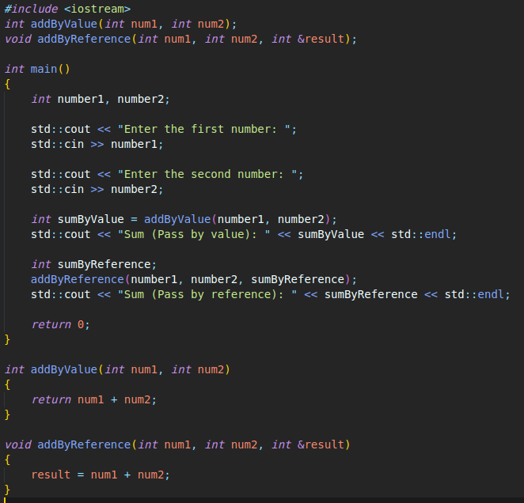

OUTPUT

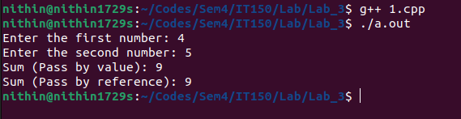

2. Write a C++ program to overloaded the functions with different arguments to calculate,
i. the area of a square, rectangle, or circle.
ii. Overloading Using Different Types of Parameters
iii.Overloading using a Different Number of Parameters

CODE

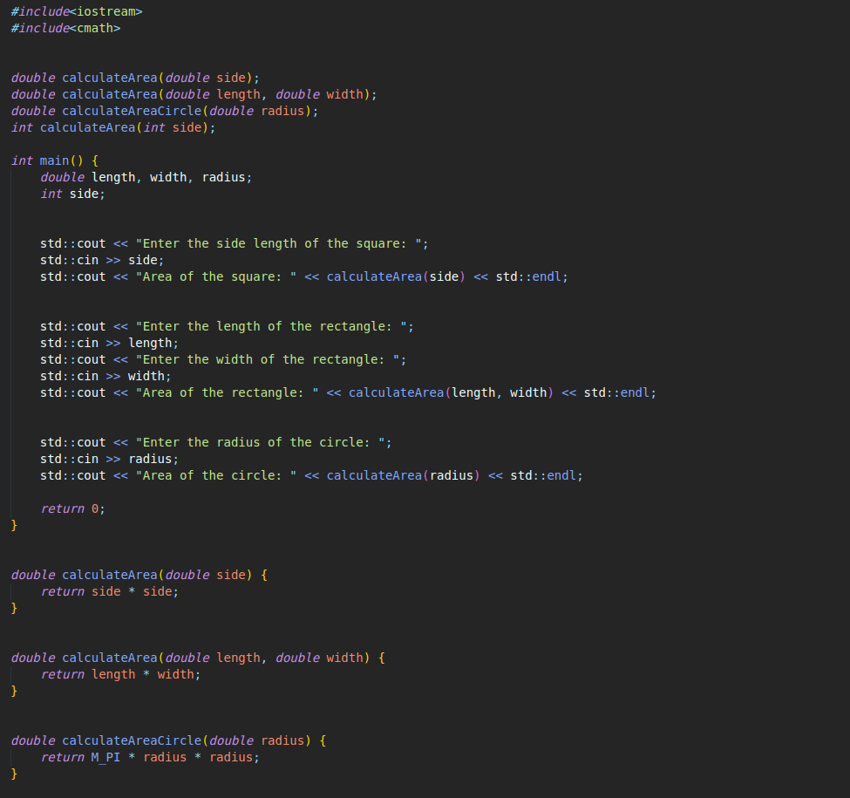

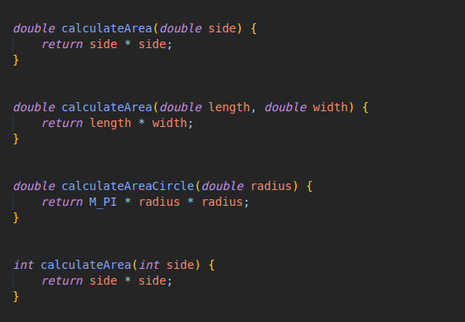

OUTPUT

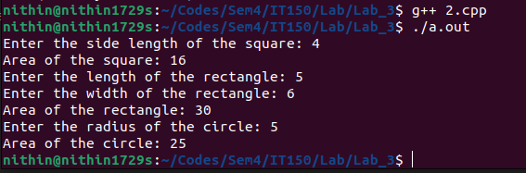

3.Write a C++ program to create Account class to manage saving account of a bank.
Define methods display_balance() and withdraw() in account class. Also define a friend
function display_info() to display basic information of account holder. Use appropriate
data types for data members. Use appropriate access specifiers in your program. Make
necessary assumptions if required.

CODE

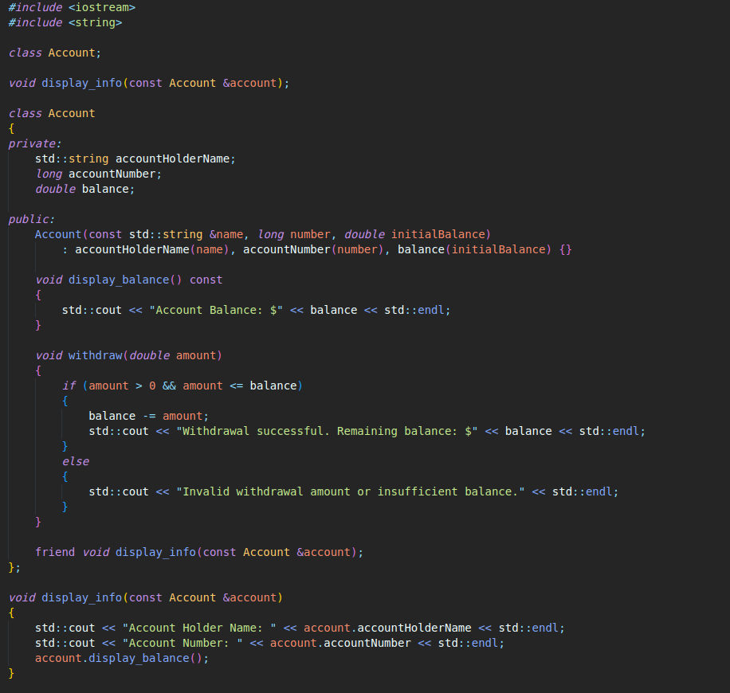

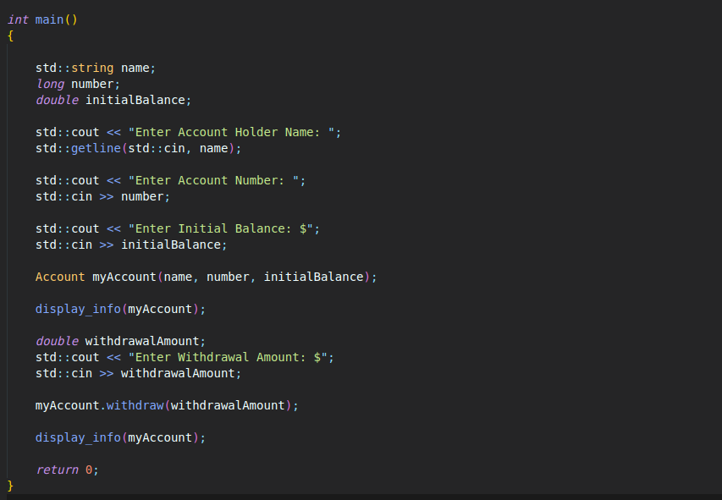

OUTPUT
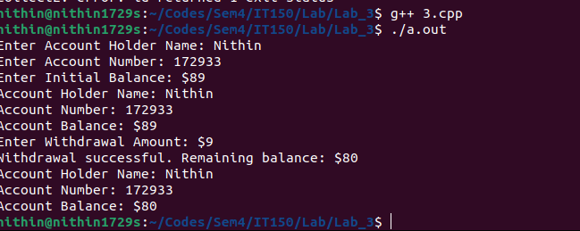

4. Write a C++ program to create a friend function for adding two matrices using two
different classes.

CODE

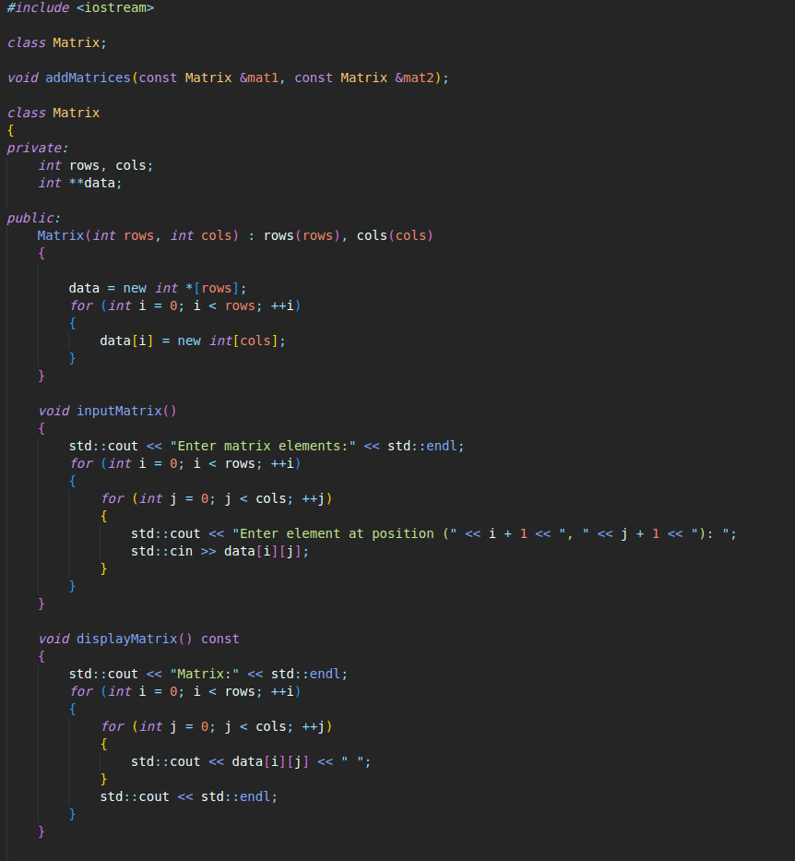

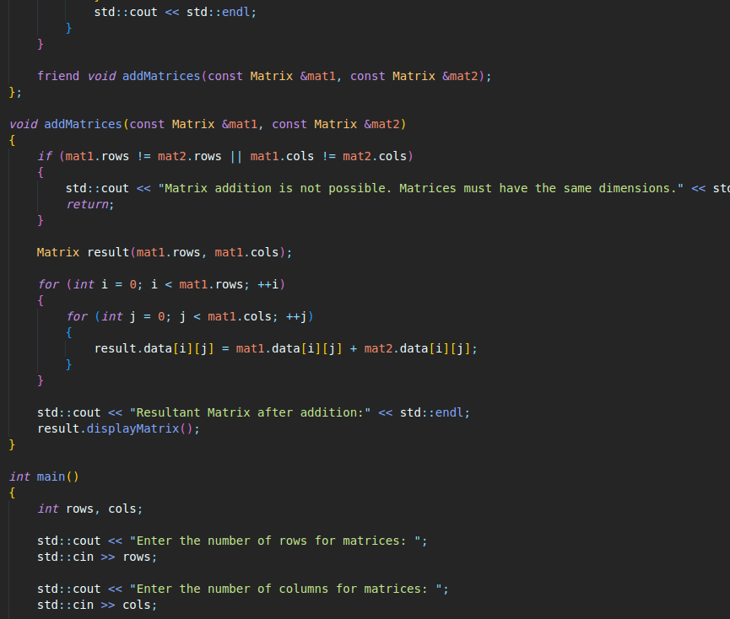

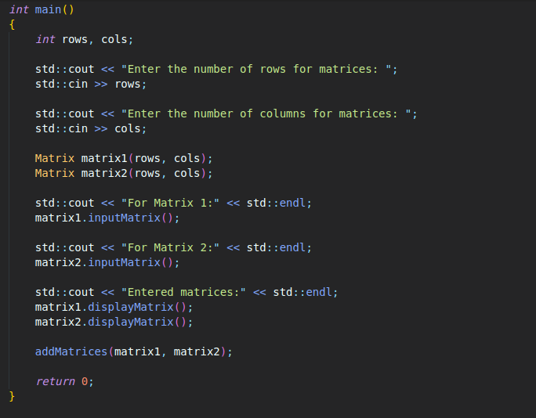
OUTPUT

